Unit -3
- Define the Critical Section Problem and explain its requirements.

The Critical Section Problem is a fundamental issue in process synchronization in operating systems.
It occurs when multiple processes or threads access and manipulate shared resources (like variables, files, or data structures) at the same time, leading to inconsistency or data corruption if not properly managed.

⚙️ Definition:
The Critical Section Problem refers to the challenge of designing a protocol that allows multiple processes to cooperate when accessing shared resources, such that only one process executes in its critical section at a time.

1. Mutual Exclusion
- Only one process can be inside the critical section at any given time.
- If one process P₁ is executing in its critical section, no other process P₂ can enter its critical section.
🧩 Example:
If one thread is updating a shared counter, another thread should not modify it simultaneously.

2. Progress
- If no process is in the critical section and some processes wish to enter, the selection of the next process to enter should not be postponed indefinitely.
- The decision must be made independently of processes that are executing outside their critical sections.
🧩 Meaning:
Processes waiting to enter the critical section should eventually get a turn — no unnecessary delays.

3. Bounded Waiting
- After a process has made a request to enter its critical section, there should be a limit on the number of times other processes are allowed to enter before it.
- This ensures fairness — no process waits forever (no starvation).
🧩 Meaning:
If process P₁ requests to enter, it must eventually get access after a finite number of turns.

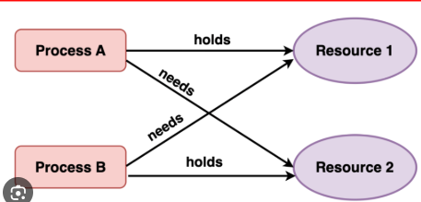

- Explain Peterson’s Solution for two-process synchronization with an algorithm and working example.

🧩 Peterson’s Solution for Two-Process Synchronization
Peterson’s Solution is a software-based algorithm that provides mutual exclusion between two processes sharing a critical section.
It ensures that only one process enters its critical section at a time and satisfies all the three requirements of the critical section problem —
✅ Mutual Exclusion
✅ Progress
✅ Bounded Waiting
1. Mutual Exclusion
- Only one process can be inside the critical section at any given time.
- If one process P₁ is executing in its critical section, no other process P₂ can enter its critical section.
🧩 Example:
If one thread is updating a shared counter, another thread should not modify it simultaneously.

2. Progress
- If no process is in the critical section and some processes wish to enter, the selection of the next process to enter should not be postponed indefinitely.
- The decision must be made independently of processes that are executing outside their critical sections.
🧩 Meaning:
Processes waiting to enter the critical section should eventually get a turn — no unnecessary delays.

3. Bounded Waiting
- After a process has made a request to enter its critical section, there should be a limit on the number of times other processes are allowed to enter before it.
- This ensures fairness — no process waits forever (no starvation).
🧩 Meaning:
If process P₁ requests to enter, it must eventually get access after a finite number of turns.
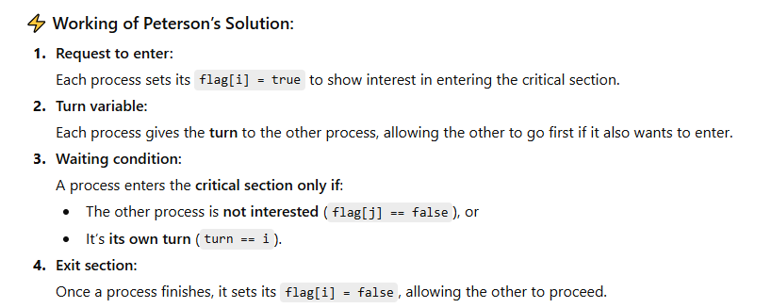
- Draw and explain the Resource Allocation Graph (RAG) model.
🧩 Resource Allocation Graph (RAG) Model
The Resource Allocation Graph (RAG) is a graphical way to represent the allocation of resources to processes and the requests made by them in a system.
It helps in detecting and understanding deadlocks in operating systems.

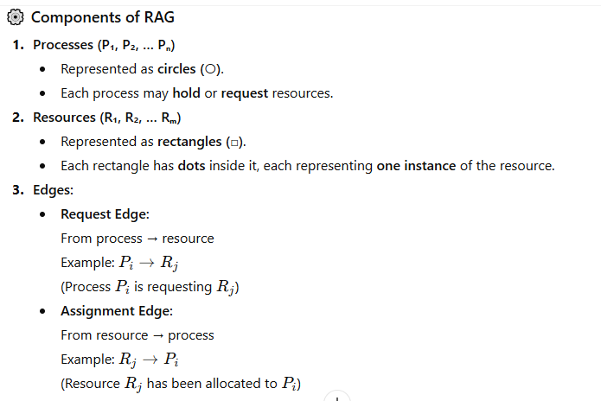
EXAMPLE:

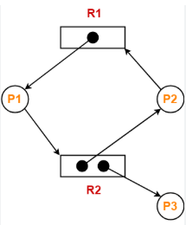
🧩 Resource Allocation Graph (RAG)
In the diagram:
- P1, P2, P3 → represent Processes (shown as circles)
- R1, R2 → represent Resources (shown as rectangles)
- Black dots inside rectangles → show instances of the resource

🔄 Explanation of Arrows:
- P1 → R2
  - Process P1 is requesting resource R2.
- R1 → P1
  - Resource R1 is allocated to process P1.
- R1 → P2 (Request)
  - Process P2 is requesting resource R1.
- R2 → P3
  - Resource R2 is allocated to process P3.

🧠 Interpretation of RAG:
- No cycle → No deadlock.
- Cycle →
  - If each resource has only one instance, deadlock exists.
  - If resources have multiple instances, a cycle may or may not mean deadlock.

- Describe dining philosophers in classical problems of synchronization with an algorithm?

- Explain Deadlock Avoidance using Banker’s Algorithm
Deadlock Avoidance using Banker’s Algorithm
Deadlock avoidance is a strategy that ensures the system never enters a deadlock state by carefully allocating resources only if the resulting state is safe. The most common method for deadlock avoidance is the Banker’s Algorithm, proposed by Dijkstra.

🧠 Concept:
The Banker’s Algorithm works like a bank that only grants loans if it is sure that the client (process) can repay them — meaning the system will remain in a safe state after allocation.
Key Terms:
- Available:
The number of available instances of each resource type.
- Max:
The maximum demand of each process for each resource.
- Allocation:
The number of instances of each resource currently allocated to each process.
- Need:
The remaining resource need of each process.
Need[i][j]=Max[i][j]−Allocation[i][j]
- Safe State Check:
- Work: A vector initialized to Available.
- Finish: A boolean vector initialized to false for all processes.
- Find a process Pi such that Finish[i] == false and Need[i] <= Work.
- If such a Pi is found:
  - Work = Work + Allocation[i] (simulating Pi completing and releasing resources).
  - Finish[i] = true.
  - Repeat the search for another such process.
- If all processes have Finish = true → Safe State (allocation is granted).
Otherwise → Unsafe State (request is denied).
- Resource-Request Algorithm:
  - When process Pi requests Request[i] resources:
    - If Request[i] > Need[i], an error occurs (request exceeds maximum declared need).
    - If Request[i] > Available, Pi must wait.
    - Otherwise (request is valid and available):
      - Temporarily modify Available, Allocation, and Need to reflect the granted request.
      - Run the Safety Algorithm with the new state.
      - If the new state is safe, grant the request permanently.
      - If the new state is unsafe, revert the temporary modifications and Pi must wait.
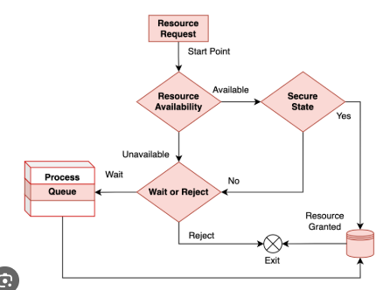

Unit -4
- Name the various Page replacement algorithms and explain anyone page replacement algorithm with example?
Page replacement algorithms decide which page to remove from memory when a new page needs to be loaded and the memory is already full.
When a page fault occurs and all memory frames are full, the operating system must replace one of the existing pages in memory. The decision of which page to replace is made using a page replacement algorithm.
Some commonly used Page Replacement Algorithms are:
- FIFO (First In First Out) Page Replacement
- LRU (Least Recently Used) Page Replacement
- Optimal Page Replacement (OPT)
- MRU (Most Recently Used)
- LFU (Least Frequently Used)
- Clock (Second Chance) Algorithm
Explain Any One Page Replacement Algorithm
FIFO (First In First Out) Page Replacement Algorithm
- FIFO replaces the oldest page in the memory.
- The page that entered first is removed first.
- It works like a queue.
Ex:
- Assume 3 frames in memory and the page reference string is:
- 7, 0, 1, 2, 0, 3, 0, 4
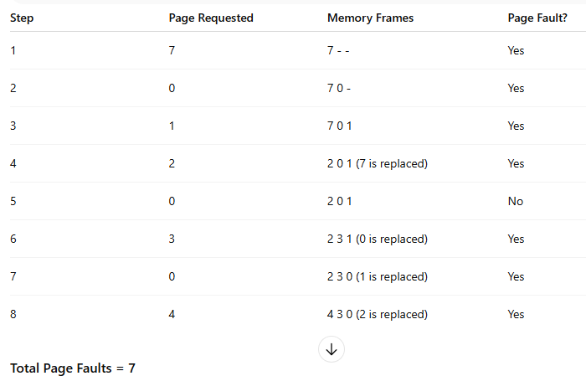
Advantages:
- Simple and easy to implement.
- Requires minimal bookkeeping.
Disadvantages:
- Performance can be poor due to Belady’s Anomaly (increasing the number of frames may increase page faults).

- Explain the working of the FCFS disk scheduling algorithm. For request sequence: 82,170,43,140,24,16,190 the head start is at request 50.
FCFS Disk Scheduling Algorithm (First Come First Serve)
Definition:
- In FCFS (First Come First Serve) disk scheduling, the requests are serviced in the order they arrive.
- There is no reordering of the request queue.
- The total head movement is calculated by the sum of absolute differences between consecutive requests.

Given Data:
- Request sequence: 82, 170, 43, 140, 24, 16, 190
- Initial head position: 50
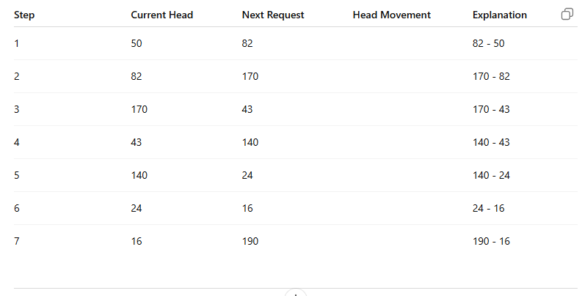
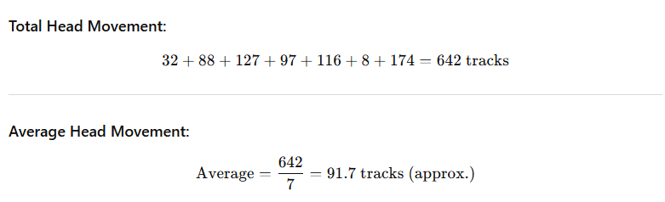
Advantages:
- Simple and easy to implement.
- Fair to all requests.
Disadvantages:
- Causes high seek time if requests are far apart.
- No optimization for minimizing head movement.

- Define demand paging and explain Copy-on-Write and its importance in process creation.
Demand paging is a memory management technique used in operating systems where pages of a program are loaded into memory only when they are needed (on demand), instead of loading the entire program into memory at once.
- When a program tries to access a page that is not in memory, a page fault occurs.
- The OS then brings the required page from secondary storage (disk) into main memory.
- This helps in saving memory, reducing loading time, and allows more processes to run simultaneously.
Example:
If a program has 100 pages but currently needs only 10 pages to execute, only those 10 pages are loaded. More pages are loaded only when required.
Advantages
- Less I/O operations.
- Fast program start-up time.
- Better memory utilization.
Copy-on-Write is an optimization strategy used when processes share the same memory pages initially, and a separate copy of the page is created only when one of the processes tries to modify the shared page.
How Copy-on-Write Works
- Parent and child share the same physical memory pages initially.
- These shared pages are marked as read-only.
- If either process tries to modify a page:
  - A page fault occurs.
  - The OS creates a private copy of that page for the modifying process.
  - The other process continues to use the old page.
This ensures copies are made only when necessary → hence the name Copy-on-Write.
Importance of Copy-on-Write in Process Creation
- Saves Memory:
Instead of copying entire memory space during process creation, pages are copied only when necessary.
- Faster Process Creation:
Since memory pages are shared initially, the creation of new processes (e.g., using fork()) becomes much faster.
- Efficient Resource Utilization:
Many processes only read data without modifying it. COW avoids unnecessary copying, improving overall system performance.
- Reduces Overhead:
Memory duplication is costly. COW reduces this overhead by delaying copies until absolutely required.

- Explain Paging and the Structure of the Page Table with a neat diagram
What is Paging?
- Paging is a memory management technique used to avoid external fragmentation.
In paging, the logical memory of a process is divided into fixed-size blocks called Pages, and the physical memory (RAM) is divided into the same size blocks called Frames.
- Pages → blocks in logical memory
- Frames → blocks in physical memory
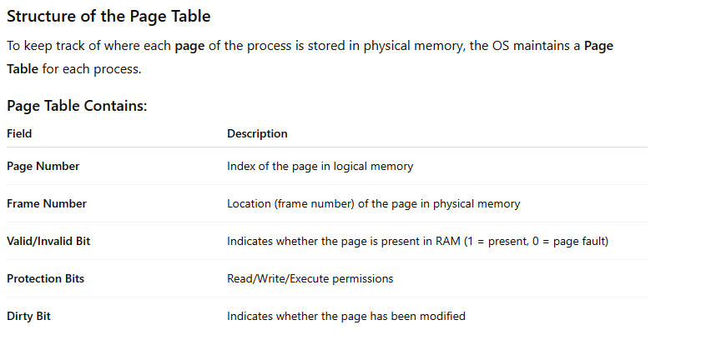
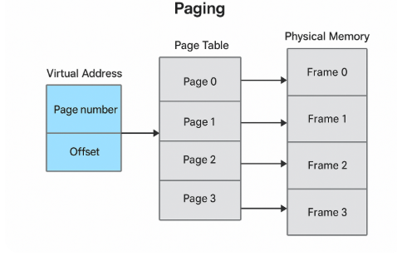
Advantages of Paging
- No external fragmentation
- Simple memory allocation
- Supports virtual memory efficiently
Disadvantages
- Requires extra memory for page tables
- May lead to slower access due to table lookup (solved by TLB)

- List the various Disk-Scheduling Algorithms with examples?
Unit -5
- Define file system and explain File-System Structure with a neat diagram.
Define File System
A File System is a method used by the operating system to store, organize, retrieve, and manage data on storage devices such as hard disks, SSDs, and USB drives.
It provides a logical view of files and directories, making data access easy for users and applications.
Main Functions of a File System:
- Stores data in files.
- Organizes files into directories or folders.
- Manages access permissions and security.
- Maintains information about the files (metadata).
- Handles storage allocation and free space tracking.

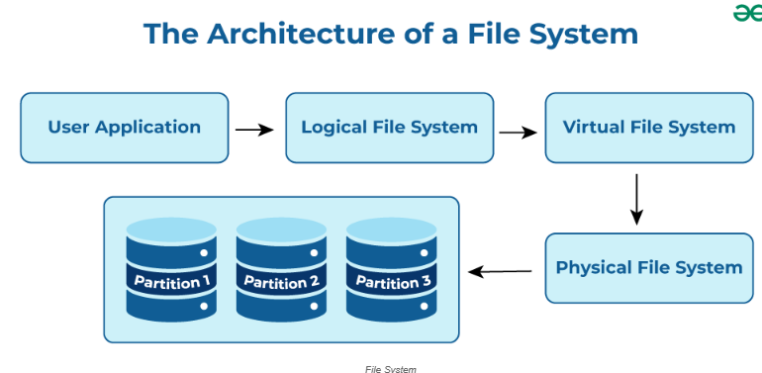
1. User Application Layer
- This is the top layer where users interact with the system through applications like text editors, compilers, or browsers.
- It sends file operation requests (like open, read, write, or delete) to the operating system.

2. Logical File System (LFS)
- Responsible for managing metadata — information about files such as names, permissions, and directory structure.
- Ensures access control and file protection.
- Maintains the file organization structure (directory hierarchy).

3. Virtual File System (VFS)
- Acts as a bridge between logical and physical file systems.
- Provides a uniform interface for different file systems (like NTFS, FAT32, EXT4, etc.).
- Allows the OS to access files on different devices seamlessly.

4. Physical File System
- Handles the actual storage and retrieval of data blocks on hardware devices (e.g., hard drives, SSDs).
- Manages the allocation of space on disk and reads/writes the data.

5. Storage Devices / Partitions
- The lowest layer, where data physically resides.
- A disk can be divided into partitions (Partition 1, Partition 2, Partition 3), each potentially containing a different file system.

- Explain Protection Rings and their use in hardware-based protection?
Protection Rings provided by modern CPUs (such as Intel x86 architecture) to protect system resources.
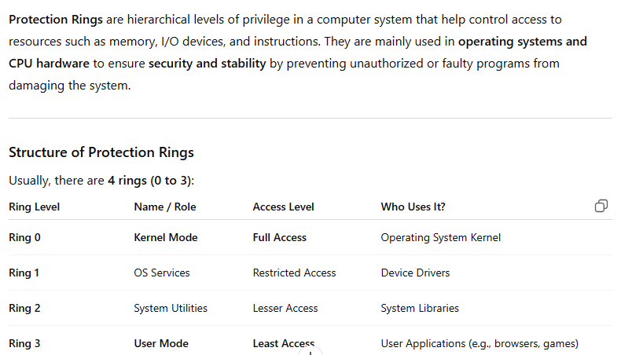

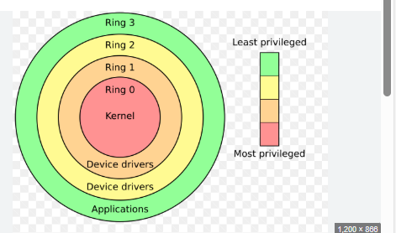
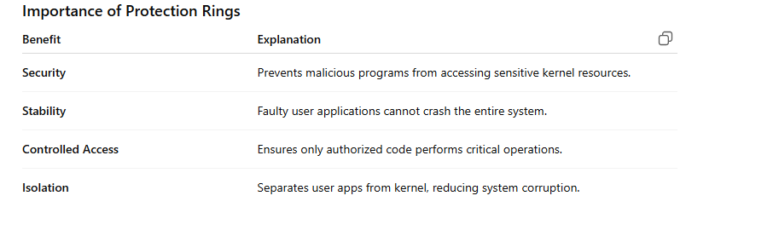
- Discuss the types of File Allocation Methods?
File allocation methods determine how file data is stored on disk blocks.
The main goal is to efficiently utilize disk space and provide fast access to files.
There are three main types of file allocation methods:

1. Contiguous Allocation
Definition:
In contiguous allocation, each file occupies a set of contiguous (adjacent) blocks on the disk.
Ex:
Disk Blocks: 0 1 2 3 4 5 6 7 8 9
File A → [2, 3, 4, 5]
File B → [6, 7, 8]
Features:
- Simple to implement.
- Access time is very fast (especially for sequential access).
Advantages:
- Easy to access sequentially and directly.
- Requires only the starting address and length of the file.
Disadvantages:
- Leads to external fragmentation.
- Difficult to extend files (need continuous free blocks).
2. Linked Allocation
Definition:
In linked allocation, each file is a linked list of disk blocks that may be scattered anywhere on the disk.
Each block contains a pointer to the next block.
Diagram:
File A: 5 → 9 → 13 → 2 → NULL
Features:
- No external fragmentation.
- Easy to grow files dynamically.
Advantages:
- Efficient use of disk space.
- Suitable for sequential access.
Disadvantages:
- Random access is slow (must traverse the chain).
- Pointer overhead in each block reduces space.
- If a pointer is lost or damaged, file data is lost.

3. Indexed Allocation
Definition:
In indexed allocation, an index block is created for each file, which contains a list of all block addresses where the file’s data is stored.
Diagram:
Index Block for File A:
| 4 | 7 | 9 | 11 |

File A data blocks → 4, 7, 9, 11
Features:
- Each file has its own index table.
- Supports direct access efficiently.
Advantages:
- No external fragmentation.
- Fast random and sequential access.
- Easy to expand files.
Disadvantages:
- Index block requires extra space.
- If index block is lost, file data is inaccessible.

- Explain the Access Matrix Model with an example.
The Access Matrix Model is a fundamental security model used in operating systems to specify and control the rights (permissions) that subjects have on objects.
- Subjects → users, processes
- Objects → files, directories, devices, memory segments
- Rights → read, write, execute, delete, own, etc.
This model is used to define who can do what.

✅ Structure of an Access Matrix
The access matrix is typically represented as a table:
- Rows → Subjects
- Columns → Objects
- Each cell M[S, O] contains the access rights that subject S has over object O.
How It Works
- When a subject requests an operation (e.g., read file F1),
- The OS checks the access matrix entry for that subject-object pair,
- If the right is present → allow; else → deny.

✅ Example of an Access Matrix
Suppose we have 3 subjects and 3 objects:
- Subjects:
  - S1 = Alice
  - S2 = Bob
  - S3 = Process P1
- Objects:
  - O1 = File A
  - O2 = File B
  - O3 = Printer
Access Rights:
- Alice → read/write File A
- Bob → read File A, write File B
- Process P1 → print on Printer
Access Matrix:
Objects
File A File B Printer
Subjects
--------------------------------------------------
Alice R, W - -
Bob R W -
Process P1 - - PRINT

- Describe how Protection and Security differ in operating systems.

